**Homework 5 submission**

Theme of my work is a mobile app for a school. I decided to specify my work for school I graduated from, but with some little changes it also can be useful for every school.

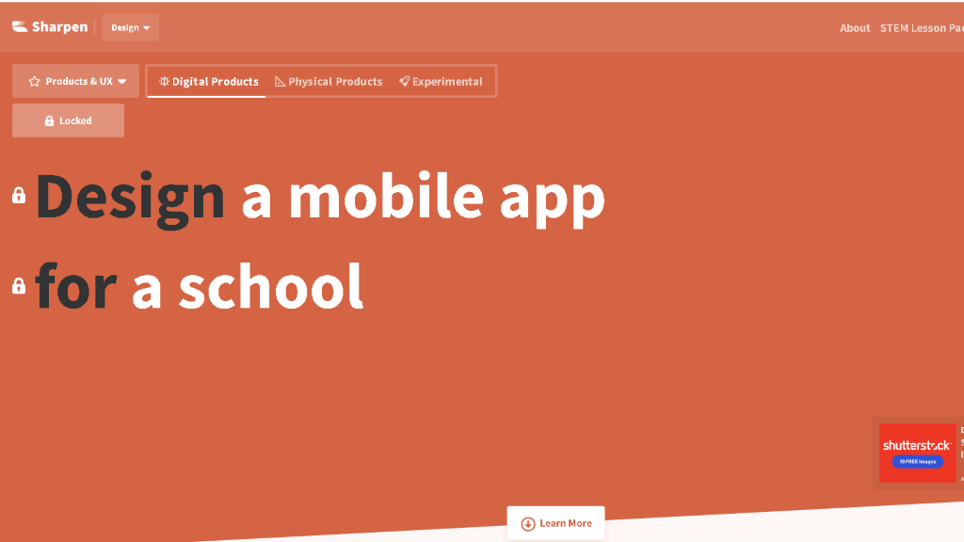

This is a homepage.

First one is light theme, second is a dark theme.

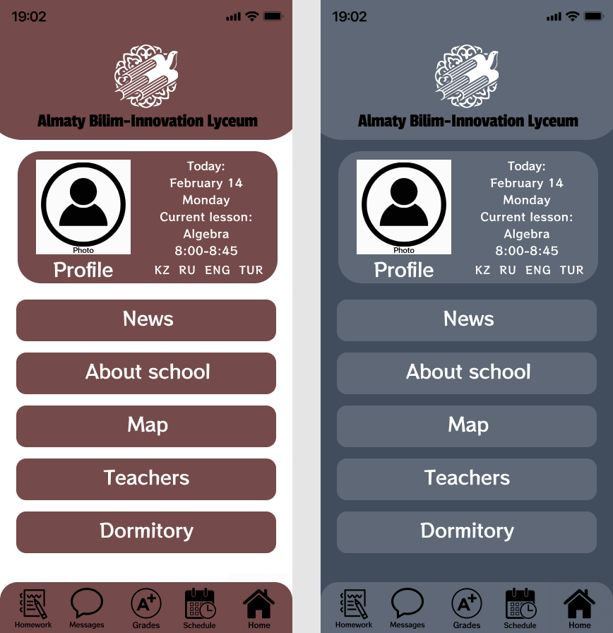

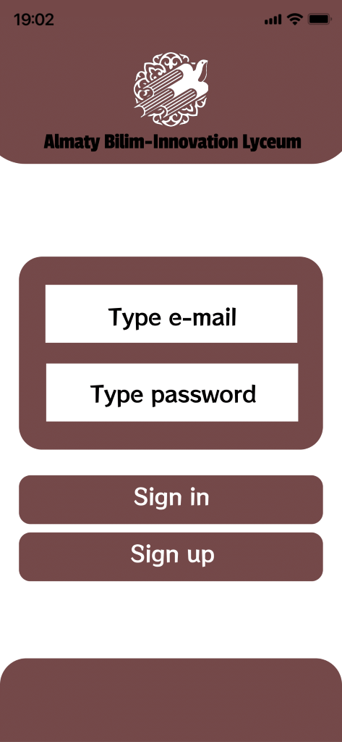

Theme of my work is a mobile app for a school. I decided to specify my work for school I graduated from, but with some little changes it also can be useful for every school.

The target audience of the app is school students of KTL(BIL) of every grade. Even its specified for this kind of school, it can be modified for everyone.

It lives on every mobile platform, also will be developed desktop version.



This is the homepage of the app with every main icons on

it.











As soon as you press any icon it will redirect you to the page you need.

All of icons represents main pages that are necessary for this type of app.

Here they are from top to down:

Schedule icon: redirects you to timetable of a student.

Homework icon: redirects you to all assignments and homeworks with detailed instructions and deadlines.

Grades icon: redirects you to page of grades of a student.

Home icon: redirects you to homepage if you are on other pages.

Messages icon: redirects you to page with chats with teachers, classmates and so on.